Methods In Window Object

1.alert() :

<html>

    <head>

        <title>Methods In Window Object</title>

    </head>

    <body>

        <h1>Methods In Window Object</h1>

        <h2>alert()</h2>

        <button onclick="but()">Click</button>

        <script>

            function but()

            {

                alert("Hello!!!");

            }

        </script>

    </body>

</html>

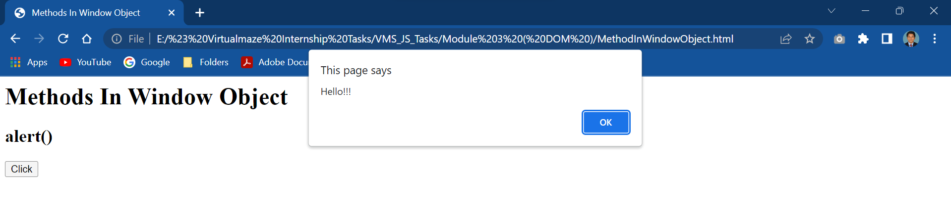

2.blur() :

<html>

<body>

<h2>The blur() Method</h2>

<button onclick="myFunction()">Try it</button>

<script>

function myFunction() {

  var myWindow = window.open("", "", "width=400, height=500");

  myWindow.blur();

}

</script>

</body>

</html>

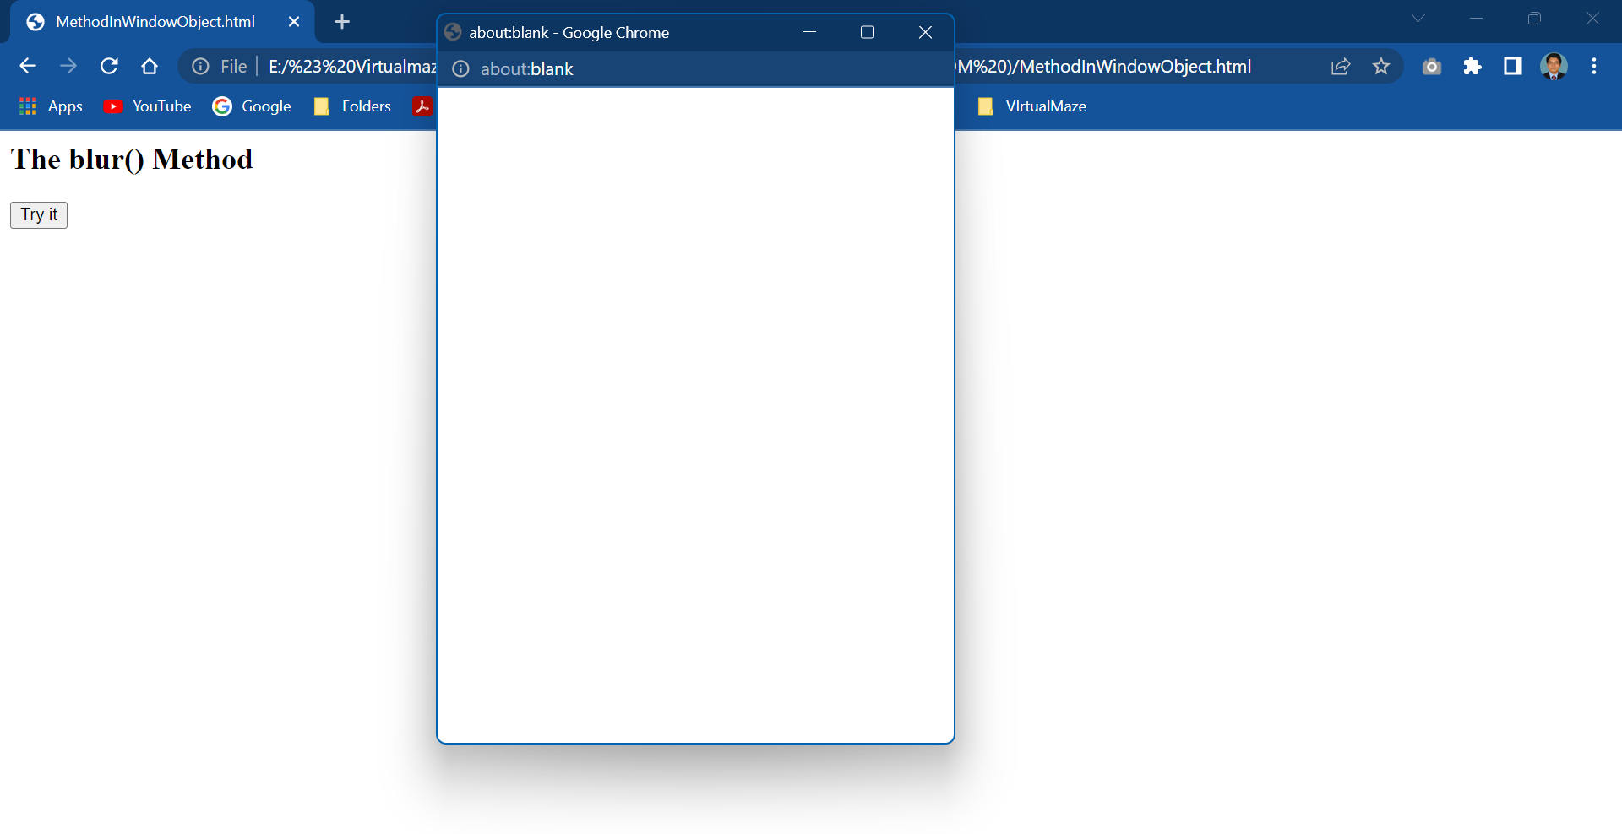

<html>

<body>

<h2>The clearTimeout() Method</h2>

<p>Click the button to prevent the timeout to execute. (You have 5 seconds).</p>

<h2 id="demo"></h2>

<button onclick="myStopFunction()">Stop it</button>

<script>

const myTimeout = setTimeout(myGreeting, 5000);

function myGreeting() {

  document.getElementById("demo").innerHTML = "Most Welcome!!!"

}

function myStopFunction() {

  clearTimeout(myTimeout);

}

</script>

</body>

</html>

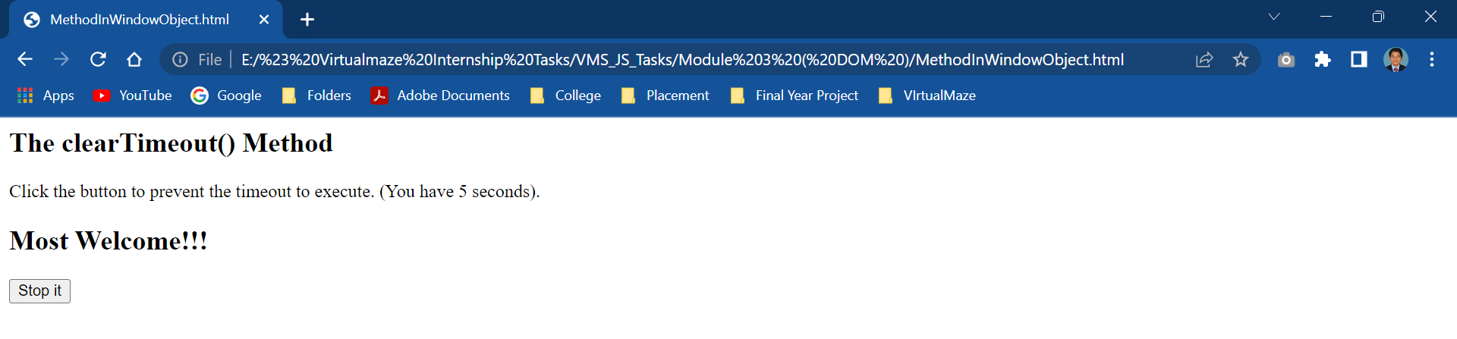

<html>

<body>

<h1>The Window Object</h1>

<h2>The open() and close() Methods</h2>

<button onclick="openWin()">Open Window</button>

<button onclick="closeWin()">Close Window</button>

<script>

let myWindow;

function openWin() {

  myWindow = window.open("", "", "width=200,height=100");

}

function closeWin() {

  myWindow.close();

}

</script>

</body>

</html>

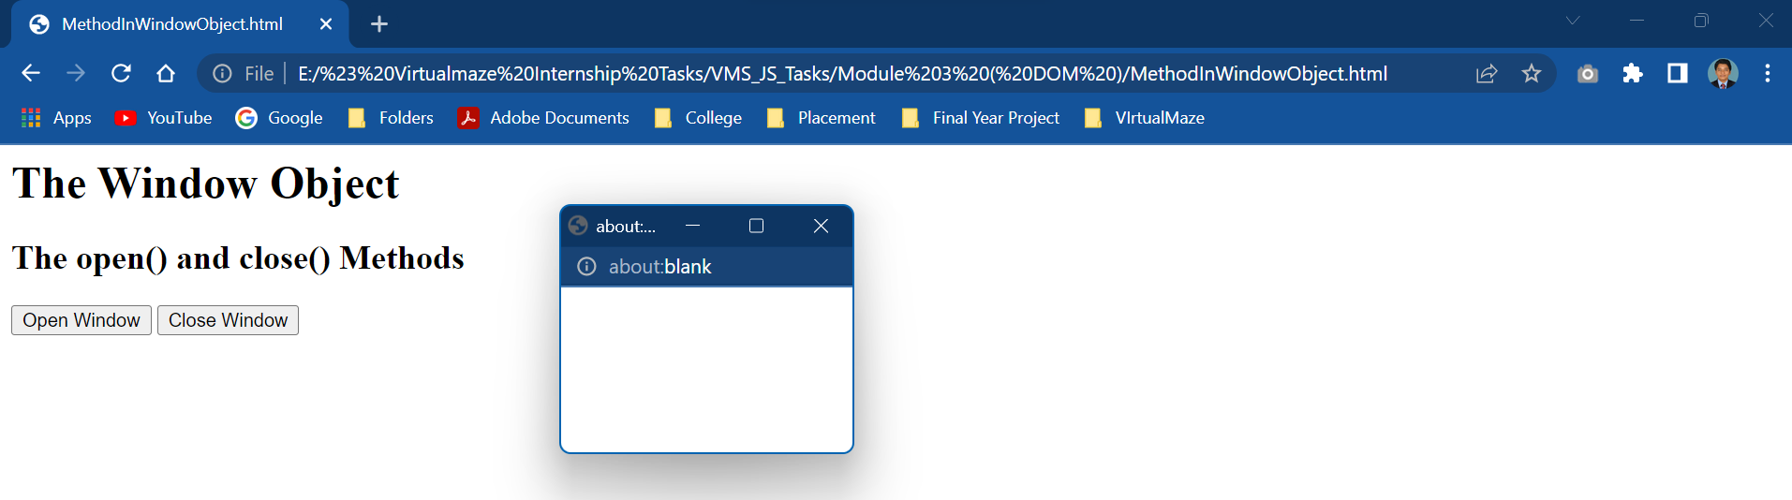

<html>

<body>

<h1>The Window Object</h1>

<h2>The closed Property</h2>

<p><button onclick="openWin()">Open "myWindow"</button></p>

<p><button onclick="closeWin()">Close "myWindow"</button></p>

<p><button onclick="checkWin()">Is "myWindow" closed?</button></p>

<div id="demo"></div>

<script>

let Window;

function openWin() {

  Window = window.open("", "Window", "width=400,height=500");

}

function closeWin() {

  if (Window) {

    Window.close();

  }

}

function checkWin() {

let text = "";

if (!Window) {

  text = "It has never been opened!";

} else {

  if (Window.closed) {

    text = "It is closed.";

  } else {

    text = "It is open.";

  }

}

document.getElementById("demo").innerHTML = text;

}

</script>

</body>

</html>

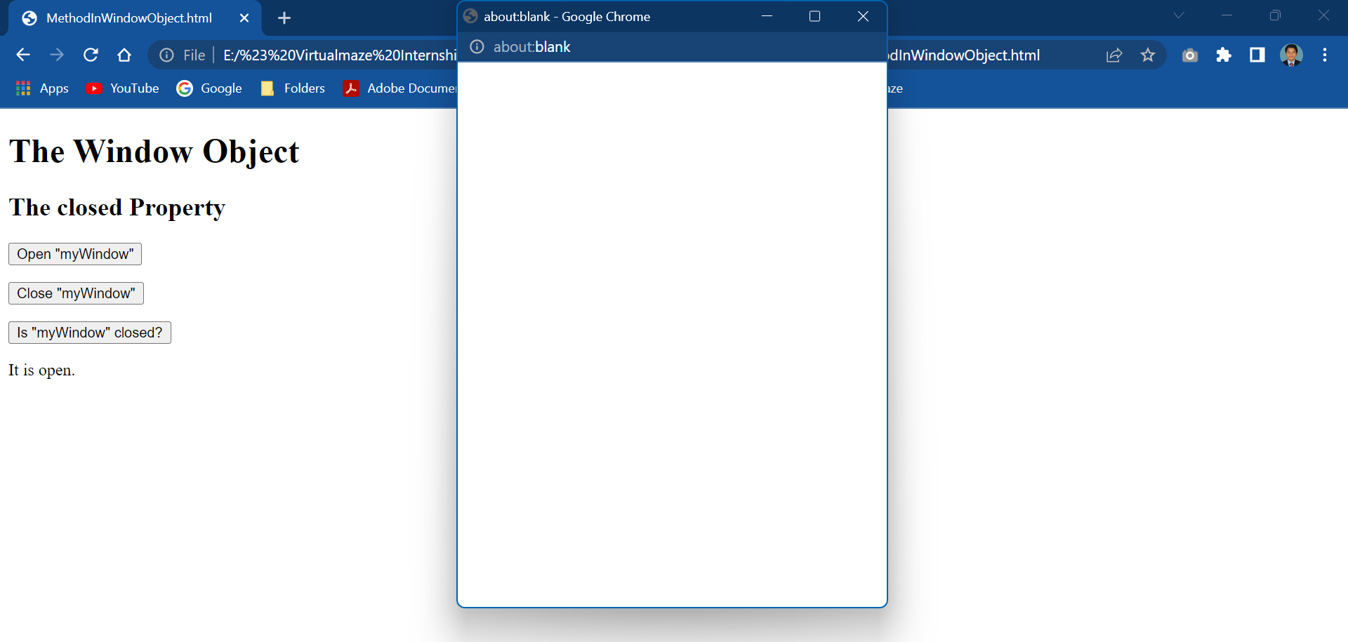

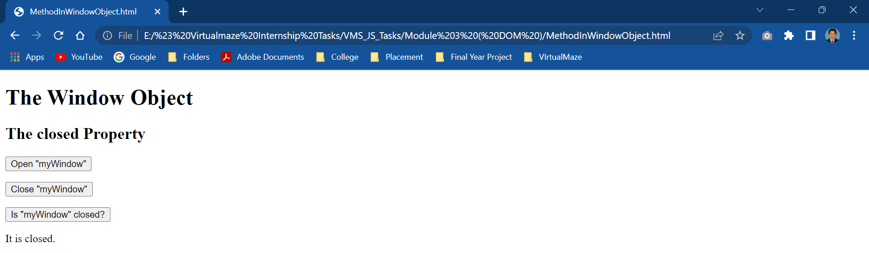

<html>

<body>

<h1>Window Document Object</h1>

<h2>The URL Property</h2>

<p id="demo"></p>

<script>

let url = window.document.URL;

document.getElementById("demo").innerHTML = url;

</script>

</body>

</html>

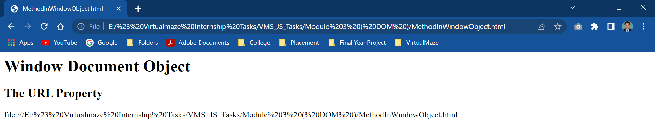

<html>

<body>

<h1>The Window Object</h1>

<h2>The innerWidth and innerHeight Properties</h2>

<p id="demo"></p>

<script>

let w = window.innerWidth;

let h = window.innerHeight;

document.getElementById("demo").innerHTML = "Width: " + w + "<br>Height: " + h;

</script>

</body>

</html>

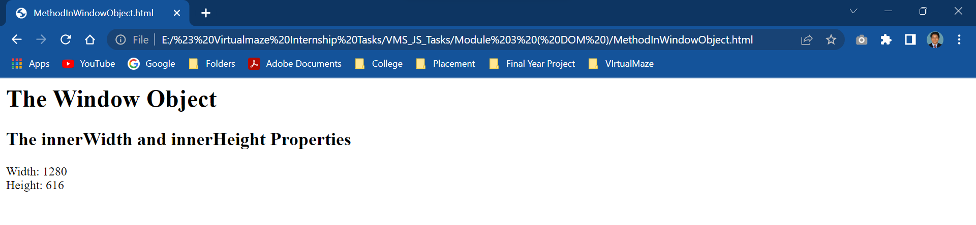

<html>

<body>

<h2>The open() Method</h2>

<p>Click the button to open a new browser window.</p>

<button onclick="myFunction()">Cick</button>

<script>

function myFunction() {

  window.open("https://www.google.com");

}

</script>

</body>

</html>

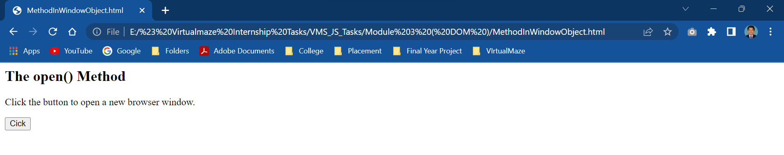

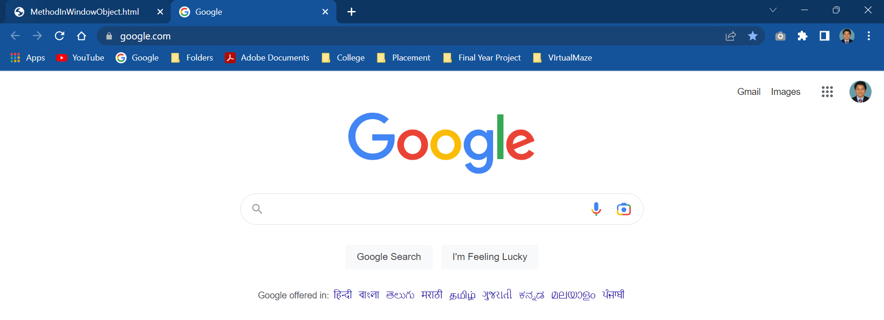

<html>

<body>

<h1>The Window Object</h1>

<h2>The opener Property</h2>

<p id="demo">

Click the button to open a new window that writes "HELLO!" in the opener window.</p>

<button onclick="myFunction()">Try it</button>

<script>

function myFunction() {

  const myWindow = window.open("", "", "width=300,height=300");

  myWindow.opener.document.getElementById("demo").innerHTML = "HELLO!";

}

</script>

</body>

</html>

<html>

<body>

<h1>The Window Object</h1>

<h2>The opener Property</h2>

<p id="demo">

Click the button to open a new window that writes "HELLO!" in the opener window.</p>

<button onclick="myFunction()">Try it</button>

<script>

function myFunction() {

  const myWindow = window.open("", "", "width=300,height=300");

  myWindow.opener.document.getElementById("demo").innerHTML = "HELLO!";

}

</script>

</body>

</html>

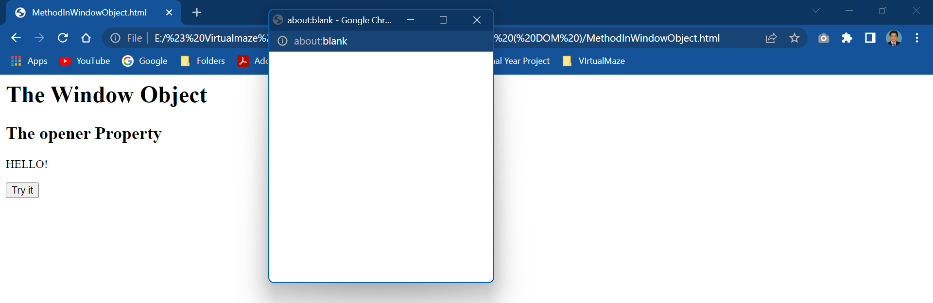

<html>

<body>

<h2>The window.print() Method</h2>

<p>Click the button to print the current page.</p>

<button onclick="window.print()">Print this page</button>

</body>

</html>

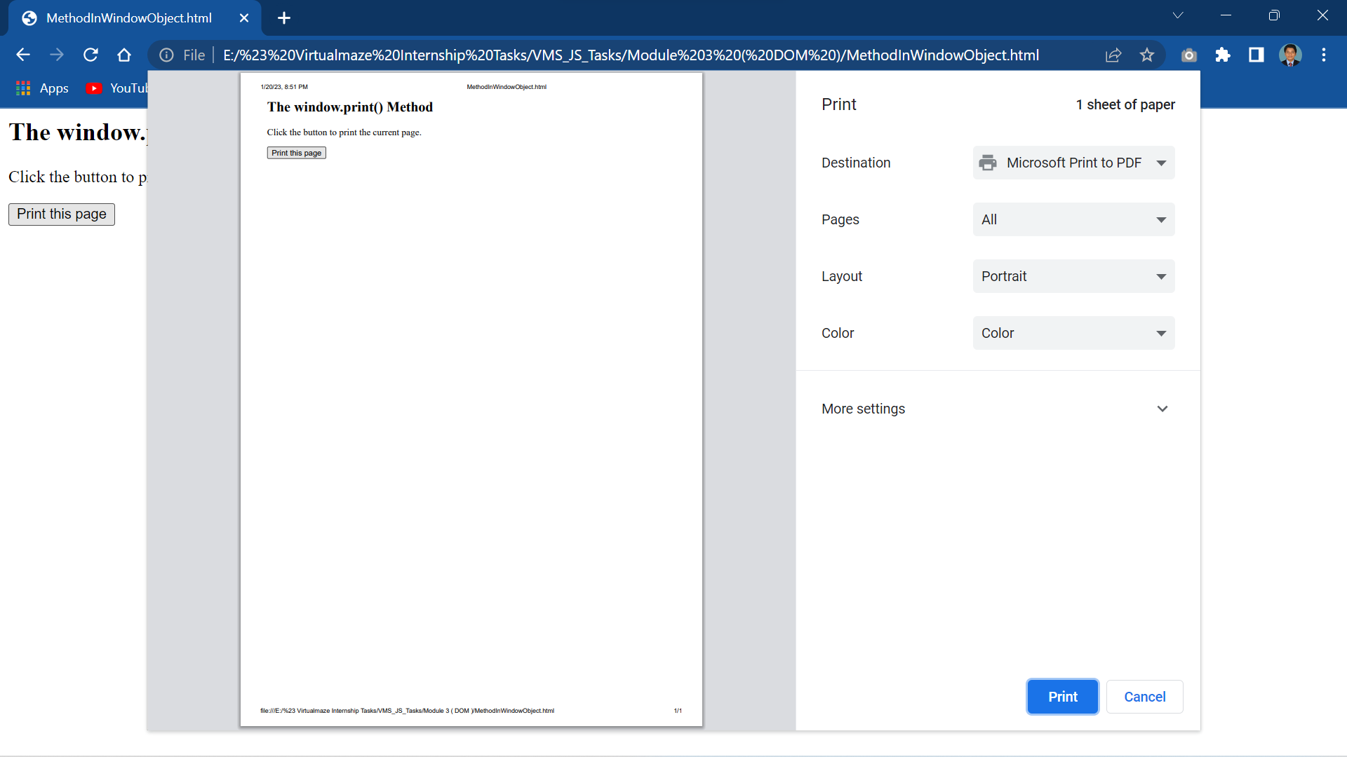

<html>

<body>

<h1>The Window Object</h1>

<h2>The prompt() Method</h2>

<p>Click the button to demonstrate the prompt box.</p>

<button onclick="myFunction()">Try it</button>

<p id="demo"></p>

<script>

function myFunction() {

  let person = prompt("Please enter your name", "Prashanna raj");

  if (person != null) {

    document.getElementById("demo").innerHTML =

    "Hello " + person + "! You must be Happy";

  }

}

</script>

</body>

</html>

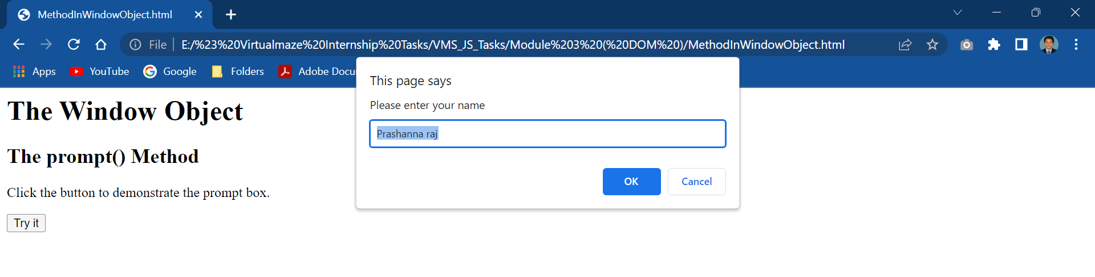

<html>

<body>

<h1>The Window Object</h1>

<h2>The setInterval() Method</h2>

<p id="demo"></p>

<script>

const element = document.getElementById("demo");

setInterval(function() {element.innerHTML += "Hello"}, 1000);

</script>

</body>

</html>

